**Programming Project 2**

Lawrence Ho

CS6364.001

**Program Output Examples for all 4 Programs**:

* Starting position: WwwwxxxxxxxxbbbB Depth: 2

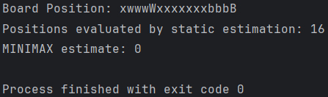 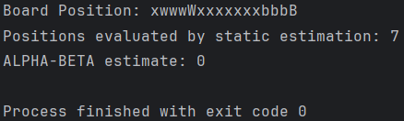 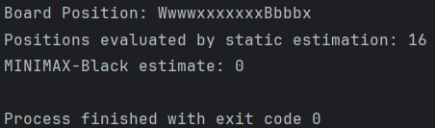 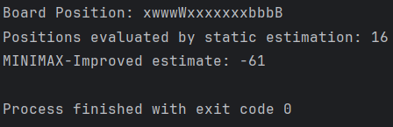

* Starting position: xwxWxwbwxxBbxbxx Depth: 5

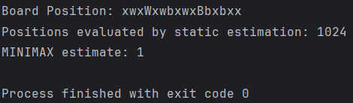 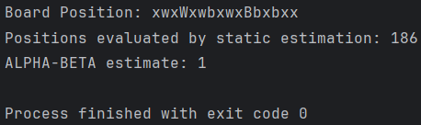 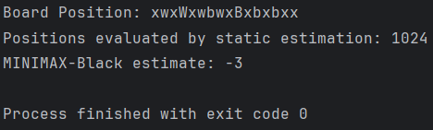 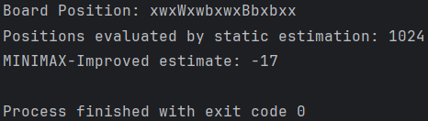

**Alpha-Beta vs Minimax**:

* Starting position: xwwxxWxBbxwxxbbx Depth: 2

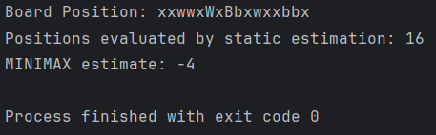 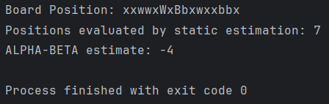

* Starting position: xwBwxbxxwbxxbxWx Depth: 4

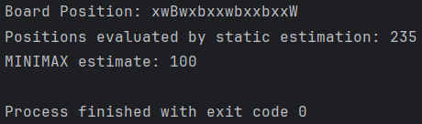 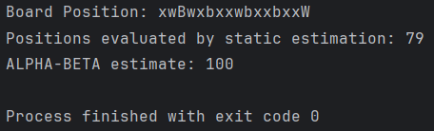

* Starting position: WxwxxbxxxwbxbxwB Depth: 10

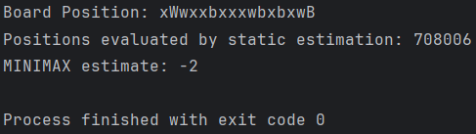 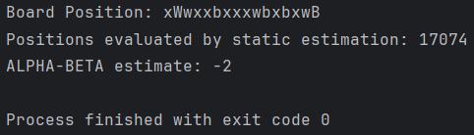

**My Static Evaluation Function vs Standard Static Evaluation Function**:

* Starting position: xbwxxxwBxWbxbwxx Depth: 10

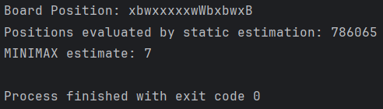 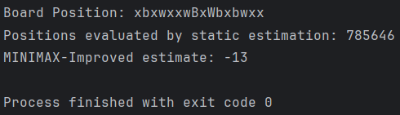

* Starting position: xWxbbxxwxxBxxxxx Depth: 3

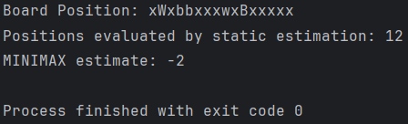

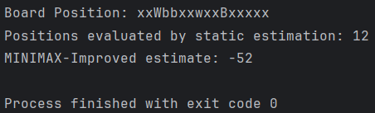

The standard static estimation function only takes into account the position of the White king and Black king. My static estimation function is better as it takes into account the kings’ positions as well as the presence and influence of pawn pieces. My estimation function evaluates the kings’ position by (whiteKingPos – blackKingPos) * 5. As the kings are evaluated separately from the pawns, the multiplication by 5 gives the evaluation of the kings more weight as the winning condition of the game is determined by the kings and not the pawns.

The pawns are evaluated by whitePawnVal – blackPawnVal, where each value is based on the number of pawns on the board as well as their position. White pawns further right have higher value and black pawns further left have higher value. The pawns are also evaluated as their presence can influence the outcome of the game, such as jumping over a single piece to send it back to its starting side. Once both the kings and pawns are evaluated, the final estimation function returns:

* 100 if the White king is off the board
* -100 if the Black king is off the board
* ((whiteKingPos - blackKingPos) * 5) + (whitePawnVal – blackPawnVal)